Face processing and the expression of race bias: Effects of between- and within-person variability in motivation to engage control.

Presenter: **Paul J. Brancaleone, M.S.**

Author list: **Paul J. Brancaleone, M.S.1**, Roberto U. Cofresi, PhD2, Hannah I. Volpert-Esmond, PhD3, David M. Amodio, PhD4, Tiffany A. Ito, PhD5, & Bruce D. Bartholow, PhD1

Affiliation list: 1University of Iowa, 2University of Missouri, 3University of Texas- El Paso, 4University of Amsterdam, 5University of Colorado- Boulder

Presenter contact: [pbrancaleone@uiowa.edu](mailto:pbrancaleone@uiowa.edu)

This poster presented a series of multilevel models which investigated the trial-by-trial effects of person construal on control over behavioral race bias, and in turn, the effect of the previous-trial conflict signal associated with control engagement on subsequent person construal.

Please feel free to contact me for more information! Our full manuscript is currently in preparation.

Contents

Analytical Approach………………………………………………………………………………………………………………………….2

References………………………………………………………………………………………………………………………………………..3

Supplementary Figure 1………………………………………………………………………………………………………………….…4

Supplementary Figure 2……………………………………………………………………………………………………….……………5

**Analytical Approach**

To test the hypotheses that (1) greater P2 amplitudes on Black-prime trials will result in a smaller discrepancy in RT and accuracy to tools vs. guns for those high in IMS and low in EMS; and (2) greater MFN activation (i.e., more negative amplitudes) on the previous trial will predict greater P2 amplitudes, but only for those high in IMS and low in EMS, a series of multilevel models were conducted. To assess the effect of trial-to-trial fluctuations in the ERP signals, the between- and within-person components were disaggregated (see Curran & Bauer, 2011; Volpert-Esmond et al., 2018). The within-person component of each relevant ERP was allowed to interact with target type and top-down motivation to control prejudice (i.e., IMS and EMS). The between-person ERP component was entered into each model as a covariate. To reduce the number of terms in each model, and because the IMS and EMS focus only on motivations to withhold anti-Black bias, only Black-prime trials were considered, with the exception of the previous-trial MFN term in the final model which included MFN amplitudes on all possible trial types. IMS and EMS scores were grand-mean centered. Target was contrast-coded so that tools corresponded to a value of 1 and guns to -1.

To build the multilevel models, we began with the maximal model (i.e., all possible Level-1 terms included as random effects) and removed random effects until the data were sufficiently explained by the model via chi-square tests. Models which attempted to include the within-person ERP as a random effect did not converge and were not considered. The final models are given below in Wilkinson notation (see Volpert-Esmond et al., 2018):

1. RT on a given Black-prime trial ~ P2 Between + P2 Within*Target*IMS*EMS + (1+Target|Participant).
2. Probability of a correct response on a Black prime trial ~ P2 Between + P2 Within*Target*IMS*EMS + (1+Target|Participant).
3. Current-trial P2 ERP elicited by Black faces ~ MFN between + MFN Within*IMS*EMS + (1|Participant).

**References**

1. Amodio, D. M. (2010). Coordinated roles of motivation and perception in the regulation of intergroup responses: Frontal cortical asymmetry effects on the P2 event-related potential and behavior. Journal of Cognitive Neuroscience, 22(11), 2609-2617.
2. Amodio, D. M., & Swencionis, J. K. (2018). Proactive control of implicit bias: A theoretical model and implications for behavior change. *Journal of Personality and Social Psychology, 115,*255-275.
3. Amodio, D. M., Bartholow, B. D., & Ito, T. A. (2014). Tracking the dynamics of the social brain: ERP approaches for social cognitive and affective neuroscience. *Social Cognitive and Affective Neuroscience, 9*, 385-393.
4. Correll, J., Urland, G. R., & Ito, T. A. (2006). Event-related potentials and the decision to shoot: The role of threat perception and cognitive control. *Journal of Experimental Social Psychology, 4*2(1), 120–128. <https://doi.org/10.1016/j.jesp.2005.02.006>
5. Ito, T. A., & Urland, G. R. (2003). Race and gender on the brain: Electrocortical measures of attention to the race and gender of multiply categorizable individuals. Journal of Personality and Social Psychology, 85(4), 616–626. https://doi.org/10.1037/0022-3514.85.4.616
6. Ito, T. A., & Urland, G. R. (2005). The influence of processing objectives on the perception of faces: An ERP study of race and gender perception. Cognitive, Affective, & Behavioral Neuroscience, 5(1), 21-36.
7. Monteith, M. J. (1993). Self-regulation of prejudiced responses: Implications for progress in prejudice reduction efforts. *Journal* *of Personality and Social Psychology, 65,* 469-485.
8. Amodio, D. M., Harmon-Jones, E., Devine, P. G., Curtin, J. J., Hartley, S. L., & Covert, A. E. (2004). Neural signals for the detection of unintentional race bias. Psychological Science, 15, 88-93.
9. Amodio, D. M., Devine, P. G., & Harmon-Jones, E. (2008). Individual differences in the regulation of intergroup bias: The role of conflict monitoring and neural signals for control. Journal of Personality and Social Psychology, 94, 60-74.
10. Freeman, J. B., & Ambady, N. (2011). A dynamic interactive theory of person construal. Psychological Review, 118(2), 247–279. [https://doi.org/10.1037/a0022327](https://psycnet.apa.org/doi/10.1037/a0022327)
11. Volpert-Esmond, H.I., Merkle, E., & Bartholow, B.D. (2017). The iterative nature of person construal: Evidence from event-related potentials. Social Cognitive and Affective Neuroscience, 12(7), 1097-1107.
12. Braver, T. S. (2012). The variable nature of cognitive control: A dual mechanisms framework. Trends in Cognitive Science, 16(2), 106– 113.
13. Braver, T. S., Kizhner, A., Tang, R., Freund, M. C., & Etzel, J. A. (2021). The dual mechanisms of cognitive control project. Journal of Cognitive Neuroscience, 33(9), 1990-2015.
14. Ito, T. A., Friedman, N. P., Bartholow, B. D., Correll, J., Loersch, C., Altamirano, L., & Miyake, A. (2015). Toward a comprehensive model of executive cognitive function in implicit racial bias. Journal of Personality and Social Psychology, 108, 187–218.
15. Payne, B. K. (2001). Prejudice and perception: The role of automatic and controlled processes in misperceiving a weapon. Attitudes and Social Cognition, 81(2), 181-192.
16. Plant, A. E., & Devine, P. G. (1998). Internal and external motivation to respond without prejudice. *Journal of Personality and Social Psychology, 75*(3), 811-832.
17. Curran, P. J., & Bauer, D. J. (2011). The disaggregation of within-person and between-person effects in longitudinal models of change. Annual Review of Psychology, 62(1), 583-619.
18. Volpert-Esmond, H.I., Merkle, E.C., Levsen, M.P., Ito, T.A., & Bartholow, B.D. (2018). Using trial-level data and multilevel modeling to investigate within-task change in event-related potentials. *Psychophysiology, 55*, e13044. <https://doi.org/10.1111/psyp.13044>

**Supplementary Figure 1**

The grand-average, face-locked P2 ERP waveforms.

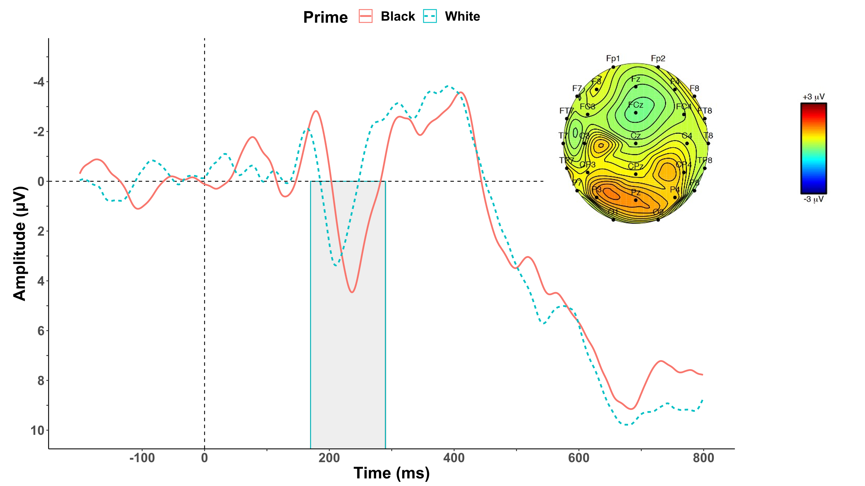

*Note.* The shaded area represents the P2 quantification window. Baseline correction was performed -200 to 0ms pre-stimulus. Grand average amplitudes elicited by Black faces (*M* = 2.01, *SD* = 2.56) was significantly greater than amplitudes elicited by White faces (*M* = 0.56, *SD* = 2.54), *t*(130) = 12.06, *p* < .001 , 95% CI [1.21, 1.69], *d* = 1.05.

**Supplementary Figure 2**

The grand-average, response-locked MFN ERP waveforms.

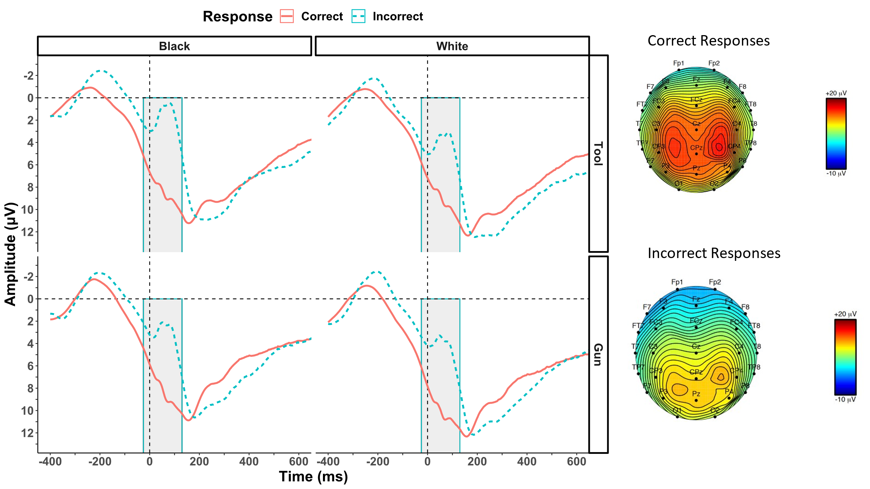

***Note.***The shaded area represents the MFN quantification window. Black-tool errors (*M* = 2.35, *SD* = 4.70) produced the largest (i.e., most negative/least positive) amplitude, *F*(1, 130) = 12.12, *p* = .002, *η*2p = 0.09. Further follow-up comparisons are available upon request.